**Project Design Phase-I**

**Solution Architecture**

|  |  |
| --- | --- |
| Date | 12 October ,2022 |
| Team ID | PNT2022TMID44952 |
| Project Name | AI Based - Real Time communication powered by AI for specially abled |
| Maximum Marks | 4 Marks |

**Solution Architecture:**

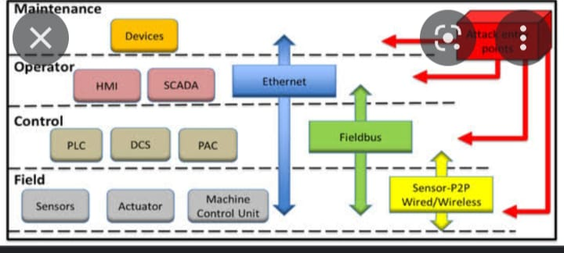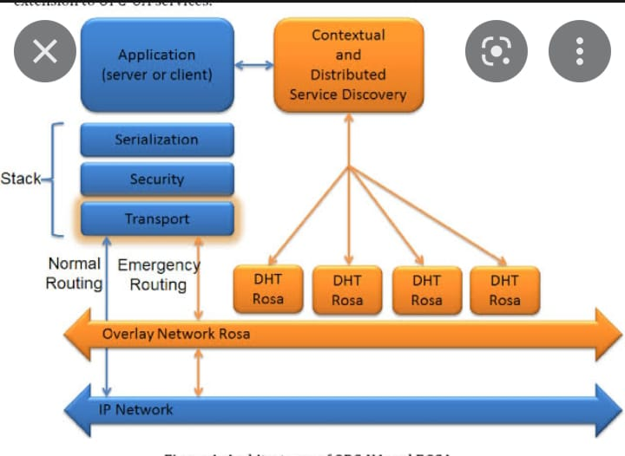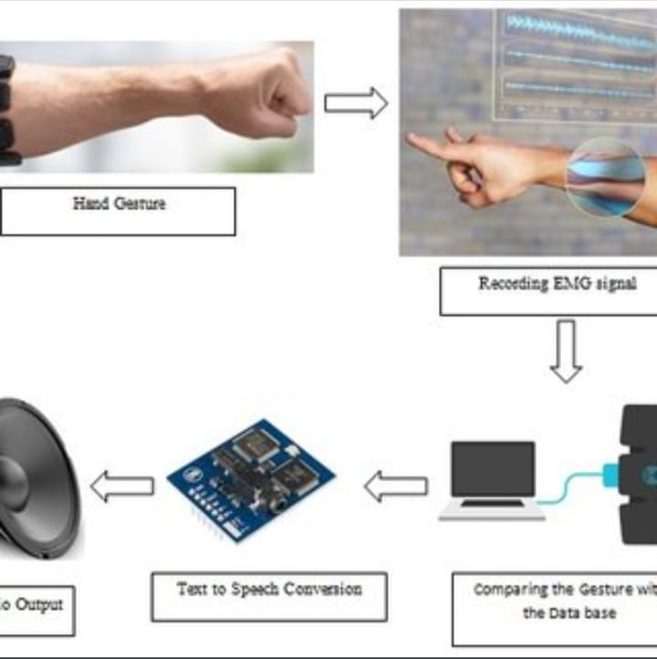

REAL TIME COMMUNICATION POWERED BY AI FOR SPECIEALLY ABLED 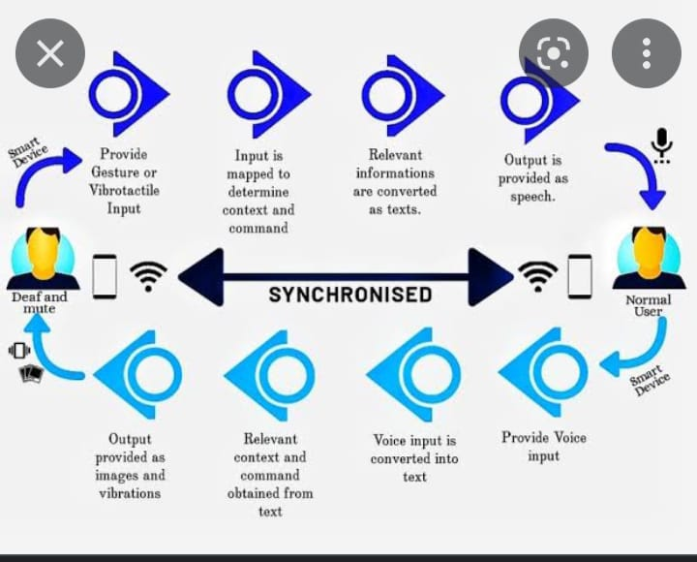

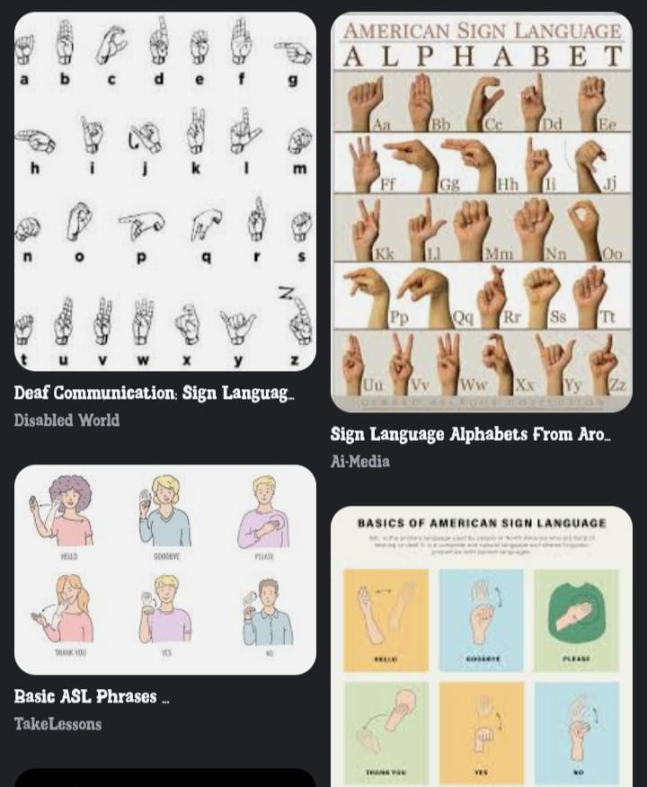

**z** 